November 20, 2021

dam van thanh

Literature review

Materials management application

# Literature Review

## Review of Domain

### Review history

As we all know, the growing and developing construction industry today is the result of labour and creative process left by mankind. From the earliest times, construction tools were very rudimentary and simple. As hidden stone caves, leaf houses to shelter from rain and sun, building models are instinctive. At the stage of hierarchical society, ancient civilizations appeared, many ancient civilized works still appear to this day such as the pyramids of Egypt, the Great Wall, the Colosseum. , Pantheon in Rome, and Hagia Sophia in Istanbul with natural materials such as trees, soil, and rocks (School, 2016). The raw material is clay-fired bricks (developed from the Phoenician discovery of a mixture of burnt lime and volcanic ash around 800 BC). The construction revolution has completely changed the construction industry when cement appeared, an invention of Joseph Aspdin in early 1824. After the process of renovation and development to have cement as it is today (Association, 2021). It is also an important historical milestone marking the development of the construction industry at that time and to this day people still use cement as an indispensable and replaceable material. Today is a breakthrough fruit of the construction industry. The introduction of new materials, new tools and the support of technology have brought the construction industry to new heights with extremely strong development.

### Current status

#### In the world

The covid-19 epidemic has spread fear in the world since the end of 2019 until now, it has always been permanent and has greatly affected the lives of mankind, the entire apparatus of each country. In particular, the construction industry is also one of the other sectors affected by this pandemic. When a series of works, the project has to be, temporarily suspended, behind schedule than expected. According to (Ankan Biswas1, 2020) the covid-19 pandemic has affected many aspects of construction such as supply chain management, Transportation problem, Labor shortage, Financial problem, Contractual implication problems, Unemployment. The fact that governments around the world implement lockdowns to control the epidemic has made it difficult for supply chain management to be disrupted, the problem of delayed transportation of goods, and a shortage of labour. shortages and cause unemployment in countries heavily affected by the epidemic.

|  |  |  |  |  |  |  |
| --- | --- | --- | --- | --- | --- | --- |
| Country | Country’s GDP shrink | Percentage of the total GDP came from construction | Construction company | Construction worker | Losses in construction | Country’s overall unemploy ment |
| INDIA | GDP of India shrinks 23.9% in Q1FY21. | The construction sector accounts for 8% of India’s GDP(at constant prices). | There are 200 firms in the construction industry in India. In addition to these, there are 120000 class A contractors in government construction industries. | There are a total 5.1crore construction workers in the country. | The impact of the Corona virus on India's construction industry is costing an estimated Rs 30,000crore every day. This pandemic will reduce investment in construction industry by 13 to 30 percent, which will probably affect gross value added and employment. | The number of unemployed d in India has risen to 27.11% due to Corona virus(COV ID-19) in the first week of May. |
| USA | Economy of U.S.A. diminish ed 4.8% in the 1st quarter of 2020 due to Corona Virus pandemic which has shut down the country. | In 2019, the value of the construction industry in the United States contributed 4.1% of GDP. | There are over 700000 construction company. | 11.2 million people work in the construction sector. | 45% of contractors are facing destruction related to the out breaks. | Corona virus outbreak raises unemploy ment by 14.7% in April 2020 and job losses reach 20.5 million. |
| CHINA | The Chinese economy shrank 6.8% in the first quarter of the year 2020. | the construction industry accounted for 6.8% of china’s GDP. The industry was valued at 894 billion USD with five percent annual growth | There are about 32900 constructio n firms. | In 2018, the number of workers in China’s construction industry was approximate ly 55.6 million. | As a result of this lockdown, all construction work has stopped and the amount of capital investment has decreased. China losses RMB 10 million from construction. | Unemploy ment rate in March 2020 was 5.9%. |
| UK | UK economy shrank by a record of 5.8% in March 2020. | Construction industry of UK contributes 6% of GDP. | There are 343,000 constructio n business in UK. | A total of 2.2 million people work directly or indirectly in the construction industry across the UK. | In this pandemic, the loss of U.K. construction industry is £301.5 million per day | UK unemploy ment rate for three months to march 2020 was estimated at 3.9% |

Table 1. The impact of COVID-19 on the GDP, construction sector and unemployment of the following countries (Ankan Biswas1, 2020)

According to (Ankan Biswas1, 2020) it is necessary to have measures and solutions to be able to adapt to a new life with the epidemic such as complying with WHO and government guidelines, allowing the freight transport system, keeping social distance, arranging seats. accommodation for workers to avoid having to move from different regions. Besides, building working models such as working remotely, applying technology and software applications. Does the government need to have financial support programs for businesses or support loans. The pandemic brings many difficulties, but it also opens up working opportunities for new working models such as remote work. It requires the information technology team to work more, bring working applications and software to employees and businesses, thereby opening up a new operational strategy for the construction industry to maintain and develop again.

At other report according to (Muzaffar Iqbal1, 2021) also share the same opinion about the effects of the covid-19 epidemic on the construction industry. In addition, they have come up with a number of models and frameworks that can be applied to the construction industry during the epidemic.

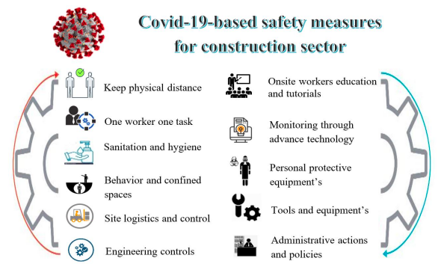

Figure 1. COVID-19 based safety measures for the construction sector

Any disaster in the world has a huge impact on economic and social activities. However, the Covid-19 pandemic is a disease that is present and living with people. Therefore, we need to have measures and frameworks that can be applied in building strategic revenue to attract investors (Association, 2021).

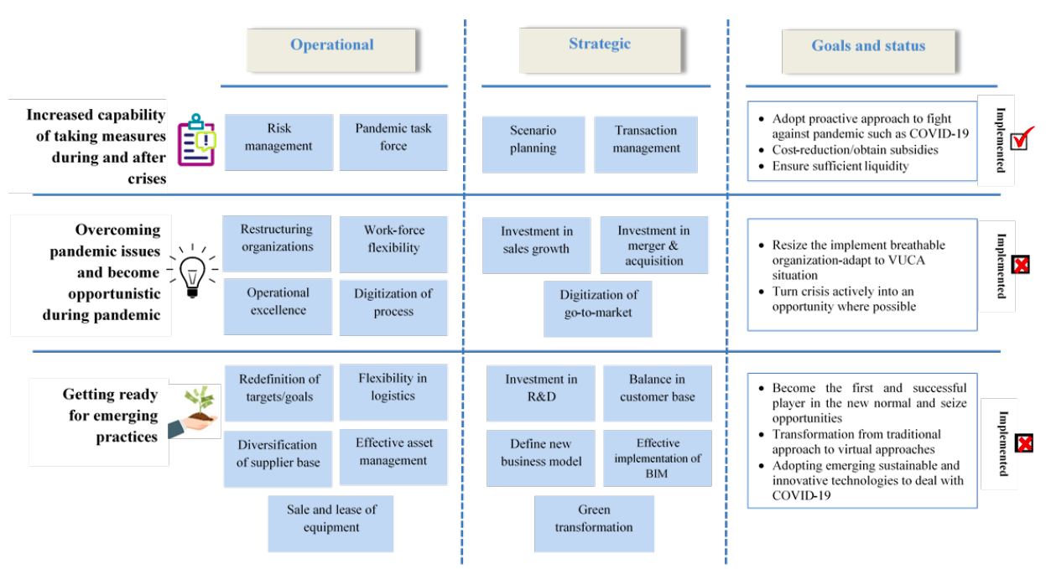

Figure 2. Proposed framework for crises management in construction sector (Association, 2021)

#### In Vietnam

According to (Nguyen, 2021) Vietnam is a country with the best performing construction industry in the Asia-Pacific region and the highest revenue growth rate in recent years.

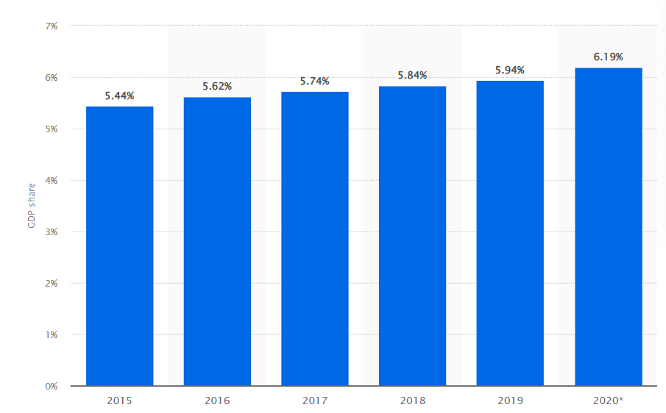

Figure 3. GDP contribution of the construction sector in Vietnam from 2015 to 2020 (Nguyen, 2021)

### Trend

### Technology

## Review of Technologies

* Review related technologies
* Compare, pros / cons

## Review of Methodologies

* Review related methodologies
* Compare, pros / cons

## Choosing solutions

* Discussion of your chosen technologies / methodologies

# References

Ankan Biswas1, A. G. A. K. T. M. B. G. a. D. K. B., 2020. *The impact of COVID-19 in the construction sector and its remedial measures,* Kalyani, West Bengal: Journal of Physics: Conference Series, Volume 1797.

Association, T. W. C., 2021. *The Long Road to Today's Portland Cement.* [Online]   
Available at: https://worldcementassociation.org/about-cement/our-history

Muzaffar Iqbal1, N. A. M. W. M. A., 2021. *COVID-19 pandemic and construction industry: impacts, emerging construction safety practices, and proposed crisis management framework,* s.l.: Brazilian Journal of Operations & Production Management.

School, A. T., 2016. *Construction History Through the Centuries.* [Online]   
Available at: https://apexschool.com/toolbox/history-construction-trade/  
[Accessed 10 11 2021].